# ABSTRACT

For future work an android application will be built to control the whole system along with desktop GUI. An emphasis will be given to provide a better optimized system with less error.

Object detection process will be made efficient and less time and power consuming. Version of code will be upgraded.

A report by World Health Organization(WHO) and International Agency for Prevention of Blindness (IAPB) stated that there are approximately 285 million peoples around the world who are visually impaired. Among these individuals, there are 39 million who are totally blind. Africa and other developing countries represent 90 percent of this statistics.

It is difﬁcult for blind people to move or live without help. There have been several systems designed to support visually-impaired people and to improve their lives. But unfortunately, most of these systems are limited in their capabilities. Almost 90 percent blind people have to depend on others to ensure their safety. So, here we have thought about a project that will give comfort to the blind people so that they don’t need others to ensure their safety.

This project deals with the home security system, not with conventional key-lock system but with a smart and rich feature. This system is featured with face detection, object detection, voice command and magnetic door lock- built in small but very powerful processor Raspberry Pi. A desktop GUI in software control and also an android app-which make this system more easier to use and very compatible. Though the project is specially targeted for blind community, any regular person can use this system easily and comfortably.

Smart Home Security System (Especially for Blind People)

# Masuda Afrin, Sanzida Mojib, Marzouka Tasnim, Zarin Tasneem, Nusrat Jahan, Farhat Lamia Military Institute of Science & Technology

CSE-16, Group-01, Section-A

FUTURE WORK

* Matching with database a voice alarm is generated to alert that known or unknown person is outside of the door.
* Getting the door is open. For the lock electric magnetic lock is used.
* After the outsider enters home, the door is automatically locked after detecting the door is its right place. It is also detected by sonar sensor.

INTRODUCTION

CONCLUSIONS

**Figure 1.** System Architecture **Figure 2.** Integrated Prototype

This system can show people, put alert in any kind of danger situation and in this system people can open and close the door through android application which can make sure them security quite a lot. So, this project will be a great help for the blind people. This will make their lifestyle more easier. This smart home security system by using technology system is successfully achieving the objective. This project is to people with disabilities that are blind to facilitate the movement and increase safety.

* To process the whole system Raspberry Pi 3 B+ is used. Input, output device, sensors all are connected to this processor.
* At first when the outsider comes to in front of the door, system recognizes him/her by the sonar sensor.
* After detection person the face detection process starts shortly and takes person’s face by webcam for further processing.
* After that it sends to its database to match if the person is known.
* Again it checks the picture taken in step 3 if the person is carrying any dangerous weapon.

CONTACT

Masuda Afrin, Sanzida Mojib, Marzouka Tasnim, Zarin Tasneem, Nusrat Jahan, Farhat Lamia

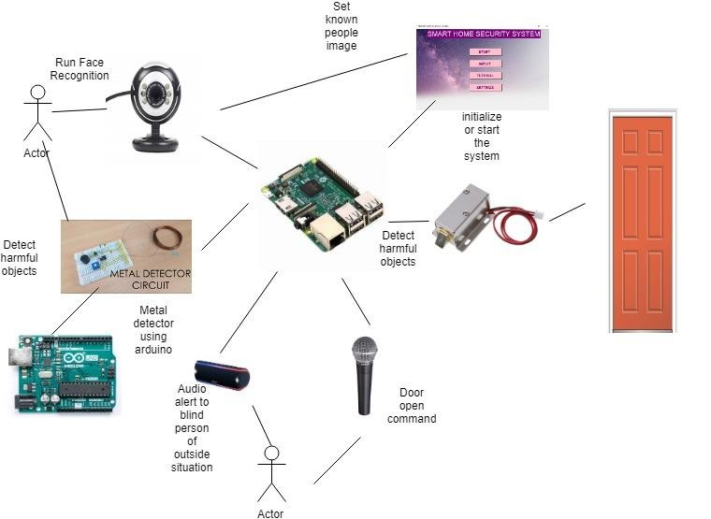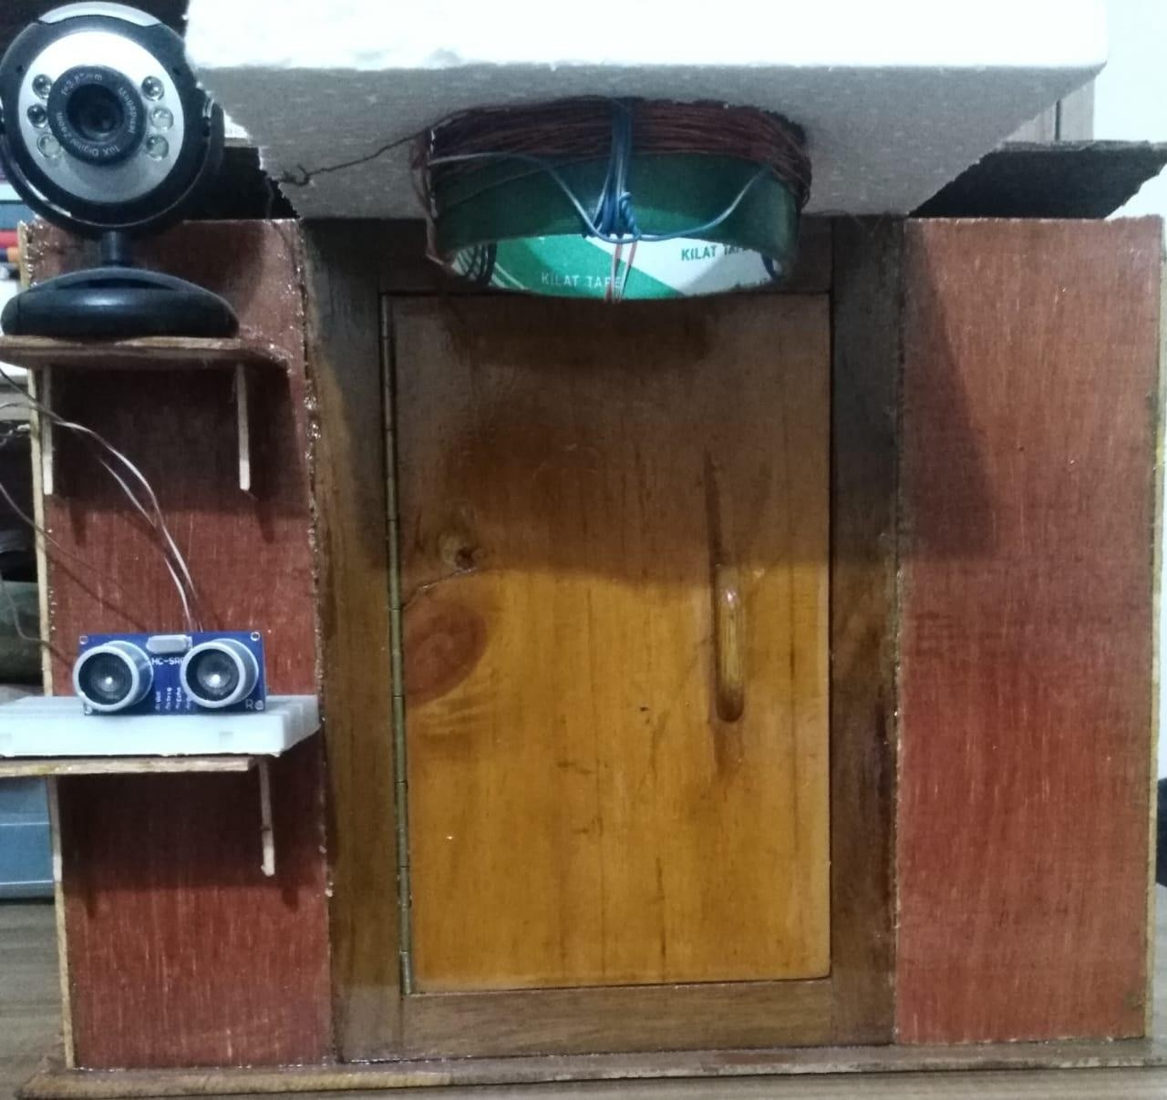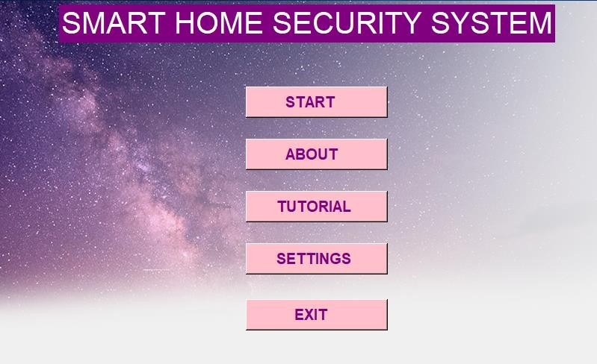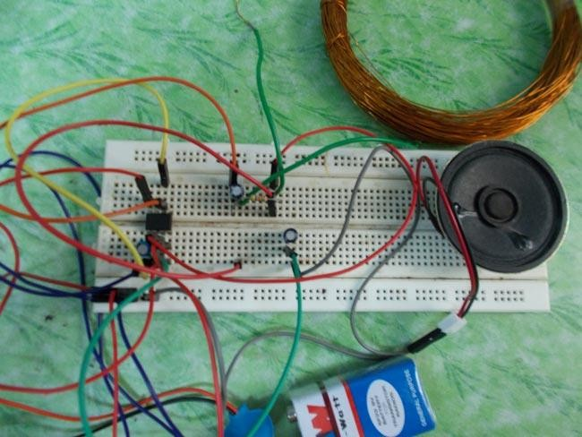

METHODS AND MATERIALS

To build this project continuous monitoring and effort have been given to make more compatible with component. A great effort has been given to integrate face detection and object detection coding as they conflict to each other if used in a same system.

In software controlling part building voice command is a great achievement which has added uniqueness to the system successfully. A desktop app is needed to run always to provide security continuously.

In face detection part 90% different faces are detected successfully. Performance is also satisfying and response is excellent.

For voice command, 98% result comes accurately. Other 2% failure is because of server connection failure.

Object detection part is time and power consuming but it detects object successfully.

DISCUSSION

RESULTS

Military Institute of Science &Technology Email: [masudatuba@gmail.com](mailto:masudatuba@gmail.com)

Phone: 01982273529

**Figure 2.** Software Part (GUI) **Table 1.** Metal Detection